Comparative Water Body Mapping Using Multiple Deep Learning Semantic Segmentation Models on Satellite Imagery

Project Charter

Project Charter Name
Comparative Water Body Mapping Multiple Deep Learning Semantic Segmentation Models on Satellite Imagery with a special focus on systematic analysis of accuracy, robustness, and architectural differences in such a systematic evaluation of the models under consistency in experimental and preprocessing conditions to utilise such models in environmental remote sensing applications.

Project Sponsor
The university under which the project is sponsored is Sheffield Hallam University in the module Advanced Artificial Intelligence Projects in Data Science, which offers academic leadership, ethical control, and quality control in the project lifecycle.

Project Purpose
The rationale is to overcome the shortcomings of conventional water body extraction techniques by making comparative analyses of deep learning semantic segmentation approach to flood monitoring, environmental management, and geospatial decision-making by use of evidence-based model selection (Li et al., 2019).

Stakeholders
The stakeholders involved are Sheffield Hallam academic supervisors, student researchers, environmental scientists, disaster management authorities, geospatial analysts, and policy makers who need the proper mapping of the water bodies using satellites to make their plans and mitigate against risks.

Scope (MoSCoW Analysis)
Must: Train and evaluate four segmentation models.
Should: Use unified preprocessing and metrics.
Could: Include qualitative visual comparison.
Won’t: Implement real-time or large-scale operational deployment.

Project Goals and Objectives (SMART)
To create and test four deep learning segmentation models on the academic timeframe, attain quantifiable gains related to the Accuracy, IoU, and F1-score based on a reproducible pipeline and one benchmark satellite dataset (Chen et al., 2018).

Success Metrics
The criteria used to measure success are pixel-wise Accuracy, Intersection-over-Union, and F1-Score, which are supplemented by manual visual examination of segmentation results to evaluate its strength, impartiality, and consistent comparative results across models (Minaee et al., 2021).

Assumptions and Constraints
The project will make the proper assumption of the annotation of datasets and adequate access to computing resources. The limitations are a lack of time to train, set academic deadlines, limited hardware, and the use of a single publicly available dataset of satellite images.

Project Milestones (Gantt Overview)
Topics, dataset preparation, model development, training, evaluation, comparative analysis, documentation, GitHub validation, and final submission are the milestones that will be organised in the given order so that they can be approached in accordance with the requirements of Sheffield Hallam assessment and monitoring.
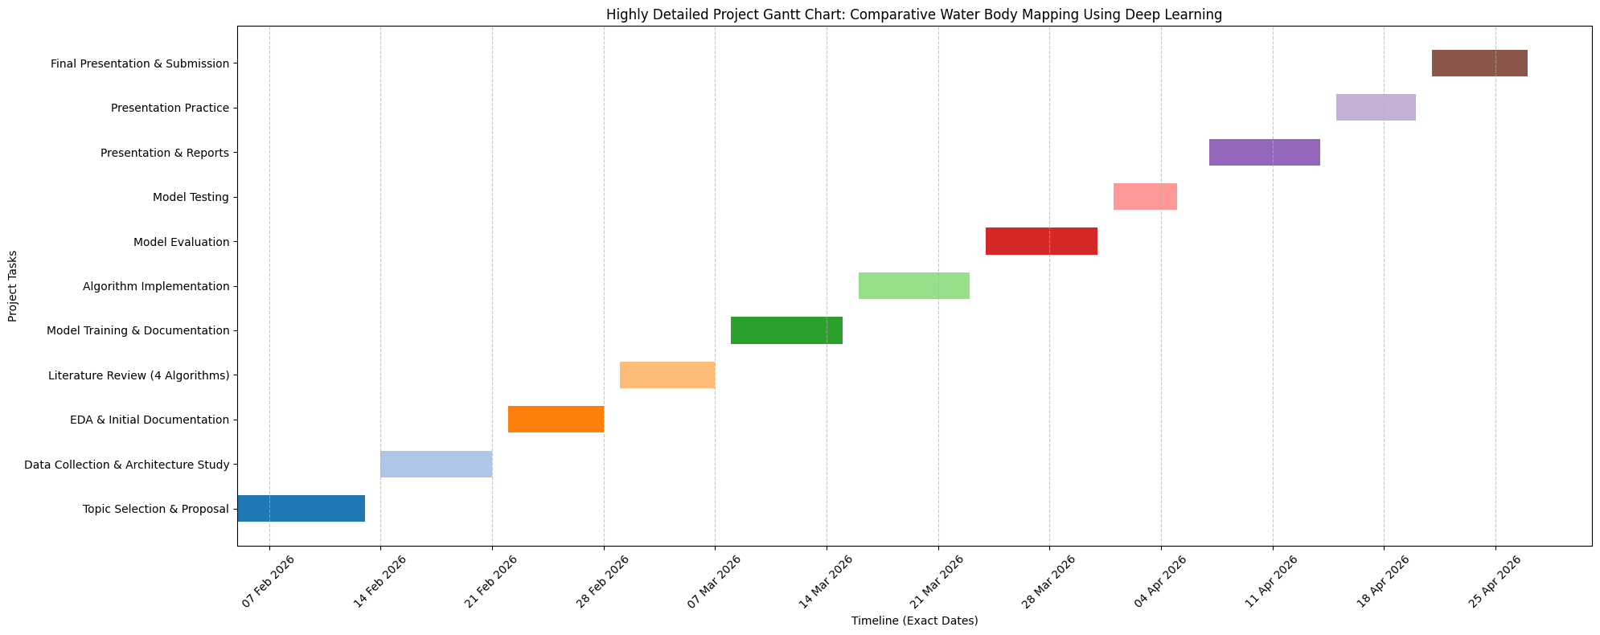
Figure 1 : Detailed Gantt Chart that will be followed during entire Project

Roles and Responsibilities (RACI Matrix)
Milestones | Project Manager | Data Engineer | Model Developer | Evaluation Lead | Documentation Lead
Project planning & scope definition | A | I | I | I | I
Dataset collection & preprocessing | I | R | C | I | I
Model selection & design | C | I | R | C | I
Model training & optimisation | I | C | R | I | I
Quantitative evaluation (Accuracy, IoU, F1) | I | I | C | R | C
Qualitative analysis & error review | I | I | C | R | C
Results interpretation | C | I | C | R | R
Report writing & formatting | I | I | I | C | R
GitHub monitoring & version control | A | R | R | R | R
Final submission & presentation | A | I | I | C | R

Table 1 : RACI Matrix
Legend:
R – Responsible | A – Accountable | C – Consulted | I – Informed

Risks
The potential risks are dataset bias, ineffective geographical generalisation, overfitting, non-uniform convergence of the model, and an inappropriate interpretation of segmentation errors, which may have an impact on environmental inferences and an ethical soundness of flood and water resources studies.

Approval /Sign-off
The agreement is confirmed by approval of scope, methodology, risks, and milestones to approve the progression into implementation and evaluation phases of the project in accordance with Sheffield Hallam University academic and ethical project policies.

